**DEPARTMENT OF THE NAVY**

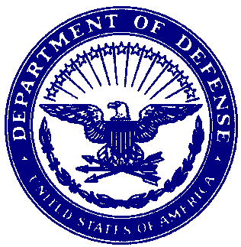

DD MMM YY

From: CDR NAME, USN, 1110/1117

To: Commander, Navy Personnel Command (PERS-410)

Via: Commanding Officer, USS XXXXXXXXXX (XXX XXX)

Subj: REQUEST FOR SURFACE WARFARE OFFICER SENIOR OFFICER RETENTION

BONUS (SORB)

Ref: (a) NAVADMIN 026/25

(b) 37 USC 332

1. I have read and understand the provisions of reference (a), including all provisions relating to termination of payments to be made under this agreement and the circumstances under which recoupment by the government of sums paid may be required, to which I agree. I hereby apply for the SWO Senior Officer Retention Bonus (SORB) authorized in reference (a).

2. Contingent upon acceptance of my application for this bonus, I agree not to tender a resignation which will be effective prior to the completion of the period obligated to under provisions of SWO SORB payment received. I understand that, upon acceptance, this application is binding, and thereupon I shall be eligible to receive the bonus discussed in reference (a) in accordance with the disbursement schedule delineated in reference (a).

Very Respectfully,

X. X. XXXXXXXX

-----------------------------------------------------------------

FIRST ENDORSEMENT DD MMM YY

From: Commanding Officer, USS XXXXXXXXXX (XXX XXX)

To: Commander, Navy Personnel Command (PERS-410)

Subj: REQUEST FOR SURFACE WARFARE OFFICER SENIOR OFFICER RETENTION BONUS (SORB)

1. Forwarded, strongly recommending approval.

X. X. XXXXXXXX

By direction

Copy to:

SVM